Hi Paula,
Don is on vacation so he asked me to send you the Construction Request. Please fill it out, just the first and last pages, read the second page requirements and email back to Don F.. We need to have a record of the tree removal and landscape requests (to attach to your POA internal property record).

If your property is not in a Resource Protection Area (RPA), then Spotsylvania County’s Chesapeake Bay Preservation rules don’t apply to you. The trees from the corner of your house out to the road are not in an RPA, but the group of trees past your house towards the lake ARE in an RPA.
Since part of your property is in a Resource Protection Area (RPA), that changes things. In Spotsylvania County (and all Virginia localities under the Chesapeake Bay Preservation Act), any disturbance of vegetation in the RPA is regulated.
Here’s what that means for you:

 What You Can Do Without Special Permission
- Normal maintenance (mowing grass, pruning shrubs, mulching, weeding).
- Pruning trees for safety (removing lower branches, trimming for health).
- Removing up to 5 dead, diseased, or storm-damaged trees (with administrative approval from the county).
  - You’ll usually need to file a short form with Environmental Services and provide photos.

 What Requires County Approval
- Removing more than 5 trees, even if they’re dead/diseased.
- Clearing live/healthy trees or shrubs in the 100-foot RPA buffer.
- Disturbing soil or grading in the RPA.
- Removing invasive species in bulk (sometimes allowed, but requires a restoration plan).
If approved, the county will often require a vegetation replacement plan — meaning you plant new native trees, shrubs, or groundcover to maintain the buffer’s water-quality function.

 What’s Generally Not Allowed
- Clear-cutting or mass removal of healthy trees in the RPA.
- Removing vegetation in the buffer without replanting.
- Disturbing the shoreline or stream bank without permits.

 Next Steps for You
- Identify if the trees you want to remove are inside the mapped RPA.
(The county GIS system or Environmental Services office can confirm.)
- Determine the reason for removal.
  - Dead/diseased → usually allowed with simple approval.
  - Healthy trees → need a permit + replacement planting.
- Contact Spotsylvania Environmental Services (Chesapeake Bay office).
  - They’ll tell you what form to file. Often it’s quick if you’re just taking out a handful of problem trees.

However, if you or your Arborist feel that this group of trees past your house pose a safety threat (like falling on a structure, ie, a house or boat house, or diseased/dead) then you would not need county approval.
Here is the GIS Map showing the RPA on your property. The dotted blue is the RPA area.
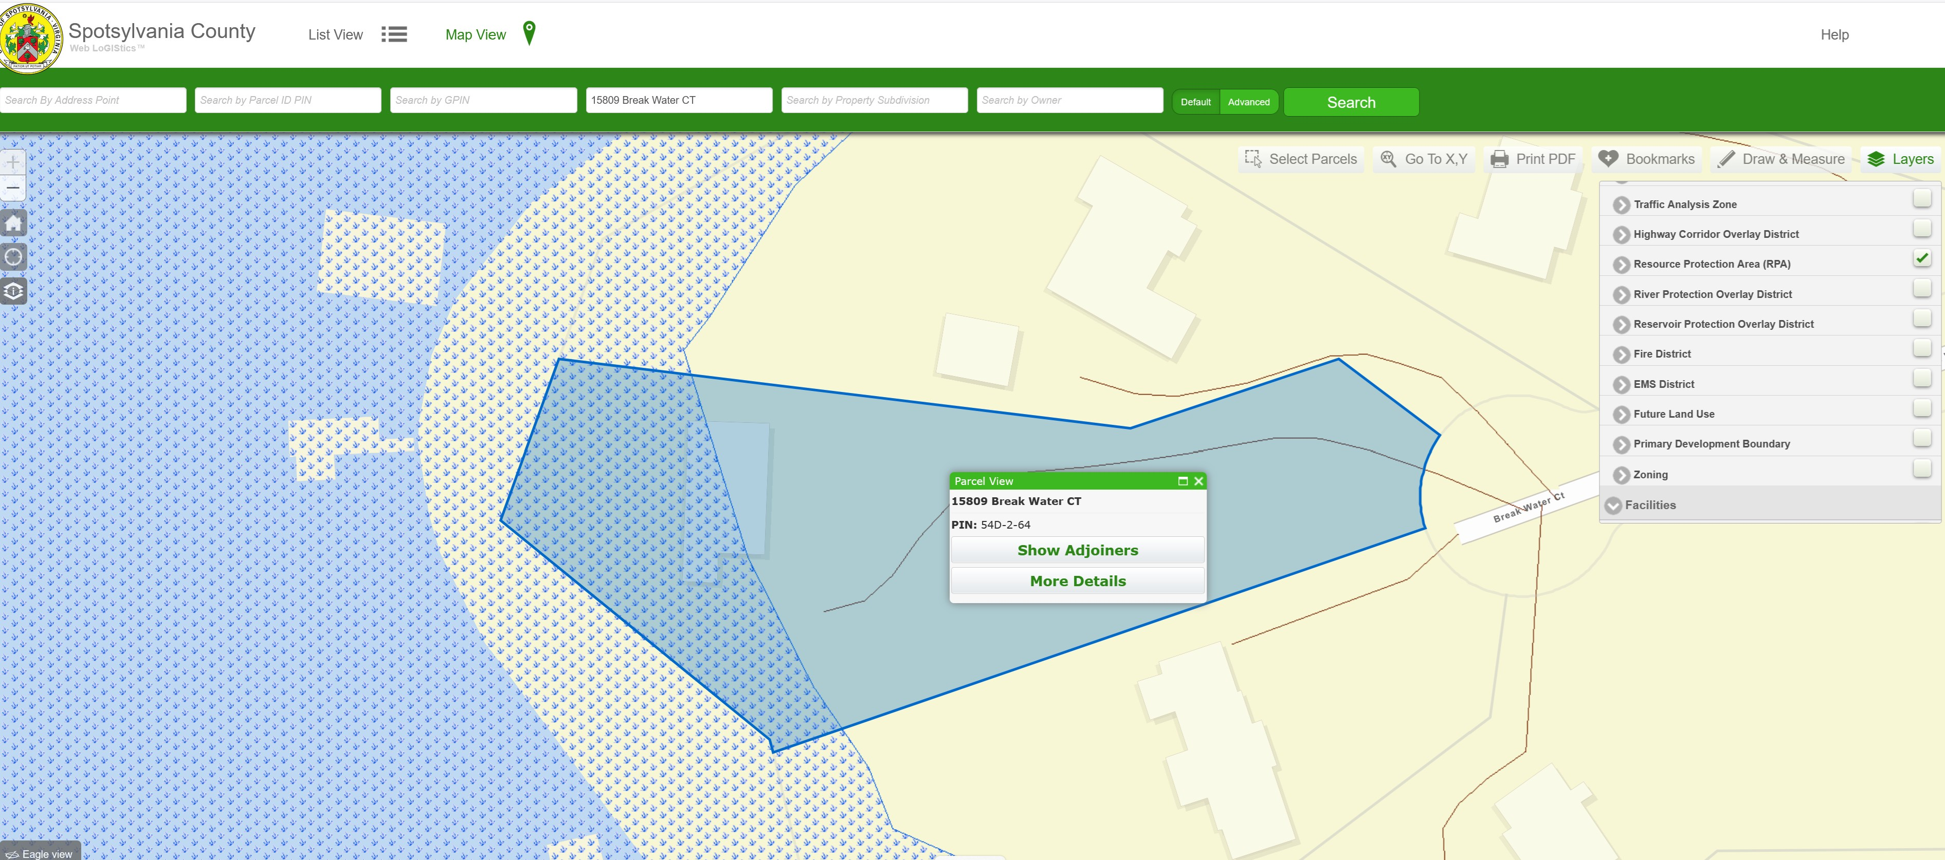​

Here are the trees you can cut down without country approval:​

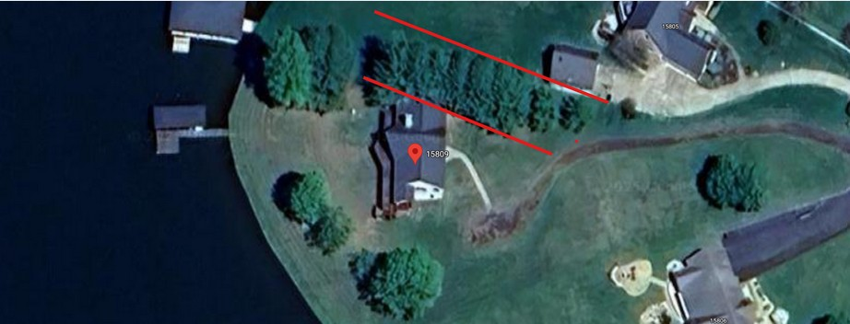​

Here are the trees you would need county approval to cut down(unless they are diseased or posed some type of safety/threat hazard like to your neighbor's boat house):

​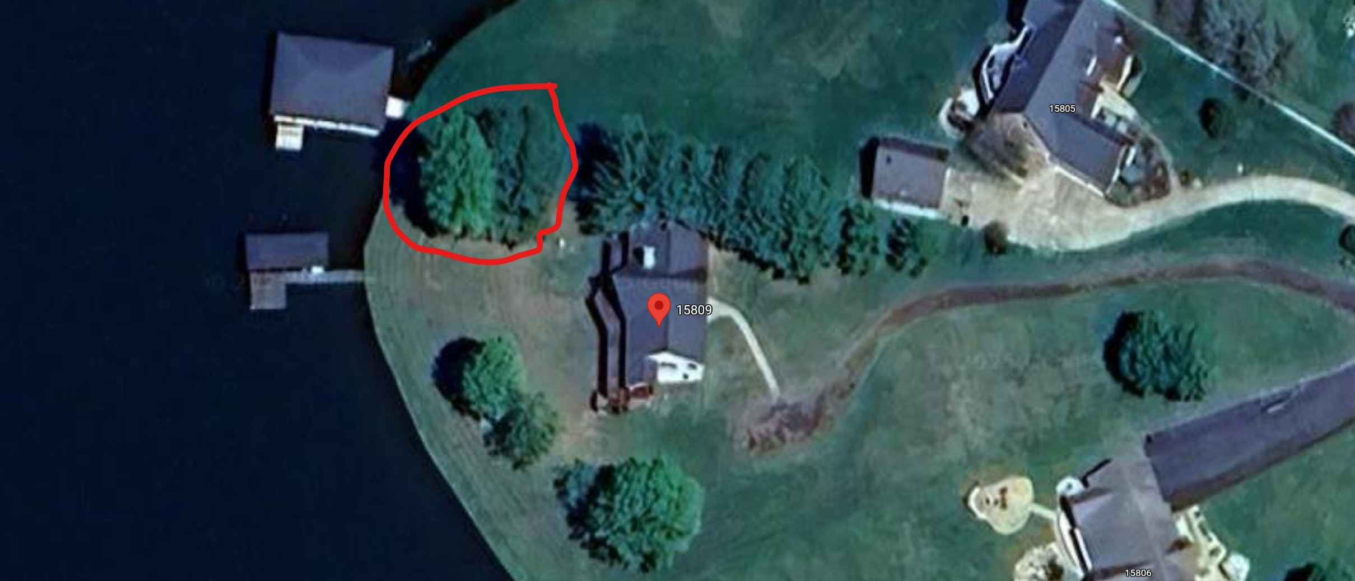​

FYI, here is Spotsylvania County's position on tree removal:
That generally means:
- For most residential lots not in an RPA:
  - You do not need county approval to cut down trees on your own property, as long as you’re not doing major grading/land disturbance.
  - Typical examples: removing a few trees for landscaping, safety, or to clear space — no permit.
- Where you would need approval outside of an RPA:
  - If your tree removal is tied to new construction, additions, or land disturbance (grading, clearing large areas, driveway/house expansions). Then you may need an Erosion & Sediment Control permit or a site plan review.
  - If you’re in a subdivision with an HOA, your HOA may have separate tree removal restrictions even if the county does not.
  - If the trees are in a public right-of-way or easement (like along the road, near utilities, or in drainage easements), you’ll need permission from the county or the utility company.
So, bottom line:
 If you’re just removing trees from your yard on non-RPA land and not disturbing large amounts of soil, you usually don’t need county approval.

And here is the language from SWS2 POA Covenants:
Key information regarding trees in Southwind Shores, Section II:
- Tree Removal Restrictions: No living tree measuring six (6) inches or more in diameter may be cut or removed without the express written approval of the Environmental Control Committee. ​ Exceptions include:
  - Trees located within twenty (20) feet of the approved site of the main dwelling or detached garage. ​
  - Dead trees or trees posing a threat to health, safety, or welfare. ​

