SOUTHWIND
SHORES II
Common Area Information Guide
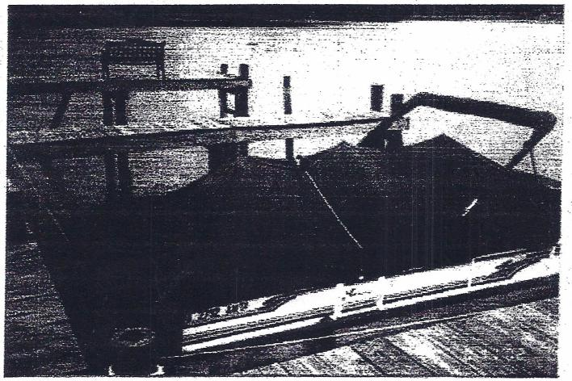
A Guide to:
-Our Dock
-Sinking Fund
-Common Area
-Boat Canopy Procedures

Southwind Shores II
- There are fifty-six (56) lots in our community
- There are 36 Water Front (WF) lots comprising 64% of the community
- There are 20 Off Water (OW) lots comprising the other 36% of the community
- Our boat dock has 26 boat slips and covers 1,770 square feet:
- 20 assigned to Off Water (OW) lots
- Each lot owner with an assigned slip is assessed $1,500 additional property tax.
- The 6 remaining unassigned slips are
classified as community property and are
untaxed under state law, Title § 58.1-3284.1
(See Appendix A).

- Under Title 55-514.1 the Board of Directors are required under law to "... conduct a study at least once every five years to determine the necessity and amount of monetary reserves required to repair, replace and restore capital components..." (see Appendix B)

QUESTIONS
How long will the current dock last?
Answer: It is constructed of Trex Composite decking, with an estimated life span of 25 plus years if properly maintained.
The dock was built in 1992 with treated lumber. In 2016, the top was replaced with Trex decking.

How much money would be needed to replace or build the current dock?
Answer: Currently the cost is $16 a square foot to build a new dock. Our dock has an estimated 1770 square feet. As of 2017, the estimated replacement cost would be approximately $30,000.
Whose responsibility is it to rebuild the
dock?
Answer: All 56 lot owners, based on the percentages outlined in the sinking fund Formula page.

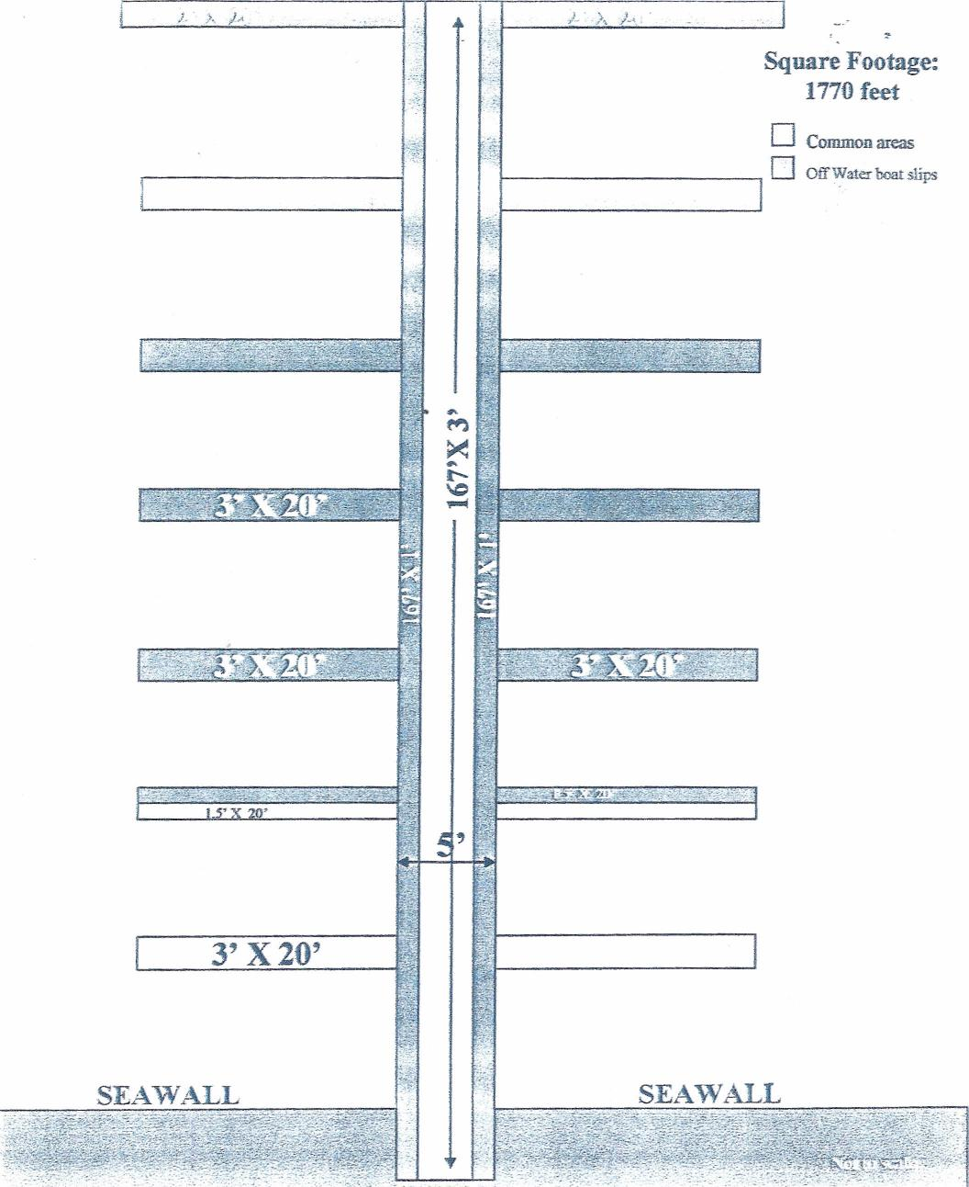
Square Footage: 1770 feet
Common areas Off Water boat slips
3' X20

Common Dock Area
(Responsibility of all 56 lot owners)
3' X 45' X 1' = 135 Sq. feet
3' X 115.5' X 1' = 346.5 Sq. feet
5' X 51.5' X 1' = 257.5 Sq. feet
1.5' X 20' X 2' = 60 Sq. feet
3' X 20' X 2' = 120 Sq. feet
Total 919 Sq. feet or 52%

Boat Slip Area
(Responsibility of 20 Off Water lot owners assigned an individual slip)
1' X 115.5' X 2' = 231 Sq. feet
3' X 20' X 8' = 480 Sq. feet
1.5 ' X 20' X 2' = 60 Sq. feet
2' X 20' X 2' = 80 Sq. feet
Total 851 Sq. feet or 48%

Formula
All 56 lot owners are responsible for the “Sinking Fund”, which is added to the POA dues.

Formula:
Fifty-two percent (52%) of the $2000 assessment is the responsibility of the 36 Water Front property owners:

Using an assessment of $2000 a year: $2000 x 52% = $1,040/56 lots = $18.57

The remaining 48% of the $2000 assessment is the responsibility of the 20 Off Water property owners, who are assigned an individual slip.

Using an assessment of $2000 a year:
$2000 x 48% = $960/20 OW lots =
$48 + $18.57 = $66.57
Final Totals per year:
Water Front (WF): $18.57
Off Water (OW): $66.57

§ 58.1-3284.1. Assessment of lots and open spaces in certain planned
development subdivisions.
A. Residential or commercial property, which is part of a planned
development which contains open or common space, which includes the
right by easement, covenant, deed or other interest in real estate, to
the use of the open or common space, shall be assessed at a value which
includes the proportional share of the value of such open or common
space.
All real property used for open or common space pursuant to this section
shall be construed as having no value in itself for assessment purposes.
Its only value lies in the value that is attached to the residential or
commercial property which has a right by easement, covenant, deed or
other interest.
"Open or common space" shall, for purposes of this section, include parks,
parking areas, private streets, walkways, recreational facilities, natural or
improved areas, lakes, ponds, recreational, community service, or
maintenance buildings or structures, or any other property used and
owned by an automatic membership corporation or association.
B. No locality shall assess real estate taxes against an automatic
membership corporation or association for open or common space except
as may be permitted pursuant to this section. Every locality shall reassess
such open or common space, and the planned development of which it is
part, as of the date of transfer of such open or common space to the
association. The developer of such planned development shall pay all real
estate taxes attributable to such open or common space at the time of transfer as provided in § 55-'1'09.1
(1985, c. 550; 1993, c. 956.)

§ 55-514.1. Reserves for capital components.
A. Except to the extent otherwise provided in the declaration and unless the declaration imposes more stringent requirements, the board of directors shall:
- Conduct at least once every five years a study to determine the necessity and amount of reserves required to repair, replace and restore the capital components;
- Review the results of that study at least annually to determine if reserves are sufficient; and
- Make any adjustments the board of directors deems necessary to maintain reserves, as appropriate.
B. To the extent that the reserve study conducted in accordance with this section indicates a need to budget for reserves, the association budget shall include, without limitation:
- The current estimated replacement cost, estimated remaining life and estimated useful life of the capital components;
- As of the beginning of the fiscal year for which the budget is prepared, the current amount of accumulated cash reserves set aside, to repair, replace or restore capital components and the amount of the expected contribution to the reserve fund for that year; and
- A general statement describing the procedures used for the estimation and accumulation of cash reserves pursuant to this section and the extent to which the association is funding its reserve obligations consistent with the study currently in effect. (2002, c. 459
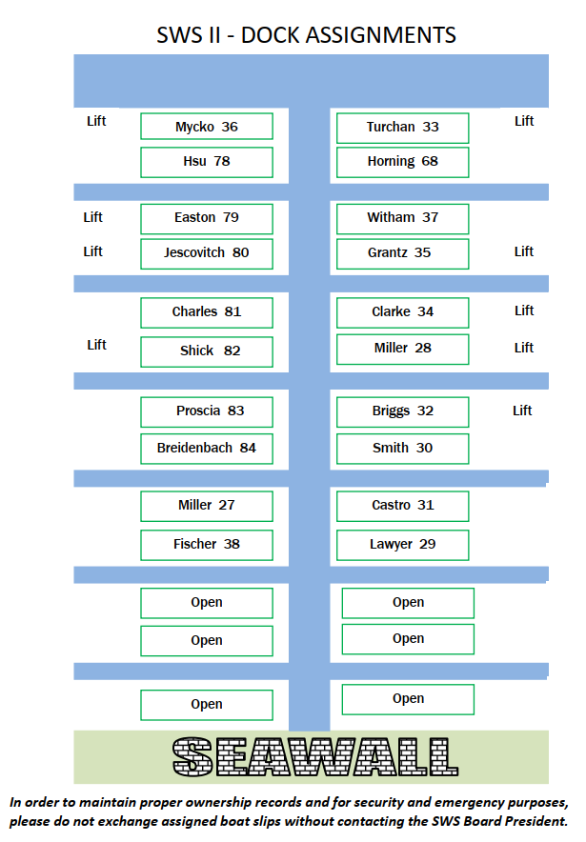
BOAT CANOPY SPECIFICATIONS

In order to provide for some continuity of structure and present a clean and pleasing appearance of the assigned dock area, the following specifications are required when submitting a request to the Board for freestanding boatlifts.

1. Traditional rounded canopy frame design, using non-corrosive metal tubing/frame material.

2. No hip roof canopy frame design.

3. Canopy must be attached to freestanding lift only—not attached to the dock.
If there is no lift, the canopy must be freestanding, but anchored to the bottom of the lake - sufficient to prevent wind-lift and potential damage to the dock/slips/boats. Should any damage occur to the dock/slips/boats, the canopy owner will be responsible for any and all repairs.

4. Canopy height maximum is six (6) feet from the dock surface.

5. Canopy cover material must be canvas.

6. Canopy color - blue (same color as other existing canopy structures).

7. Canopy cover must be removed at the end of the season.

You must submit your request in writing to the Board, with the above specifications acknowledged. If you wish to propose a change to the above specifications, you must submit a detailed, written request of the proposed changes to the Board for consideration.

Board approval is required BEFORE any canopy/structure can be erected.
Common Area Courtesy

- Spotsylvania County and SWSII POA has a leash law.
-Do NOT let your dog run loose in the common area
-Clean up after your dog in the common area.

- When using the common area for a picnic, a day at the beach, fun with the kids, etc. you need to cleanup before leaving, including collecting and removing all garbage and kid toys.

- Boat slips are assigned to each Off Water lot owner. Please tie up your boat or jet ski in your own slip.

- Properly tie up your boat to ensure that no damage is done to the dock or other boats. You will be responsible for any damage.

- The use of the pavilion is for the entire community. If you want to reserve the pavilion for a special occasion, you need to request approval of the Board through the Secretary.

- Homeowners, please be aware that the use of the Common Area by yourselves, your family and your guests, is at your own risk.

- If you are the last on to leave the Common Area, please make sure the umbrellas are down and lock the gate.

